**1.**

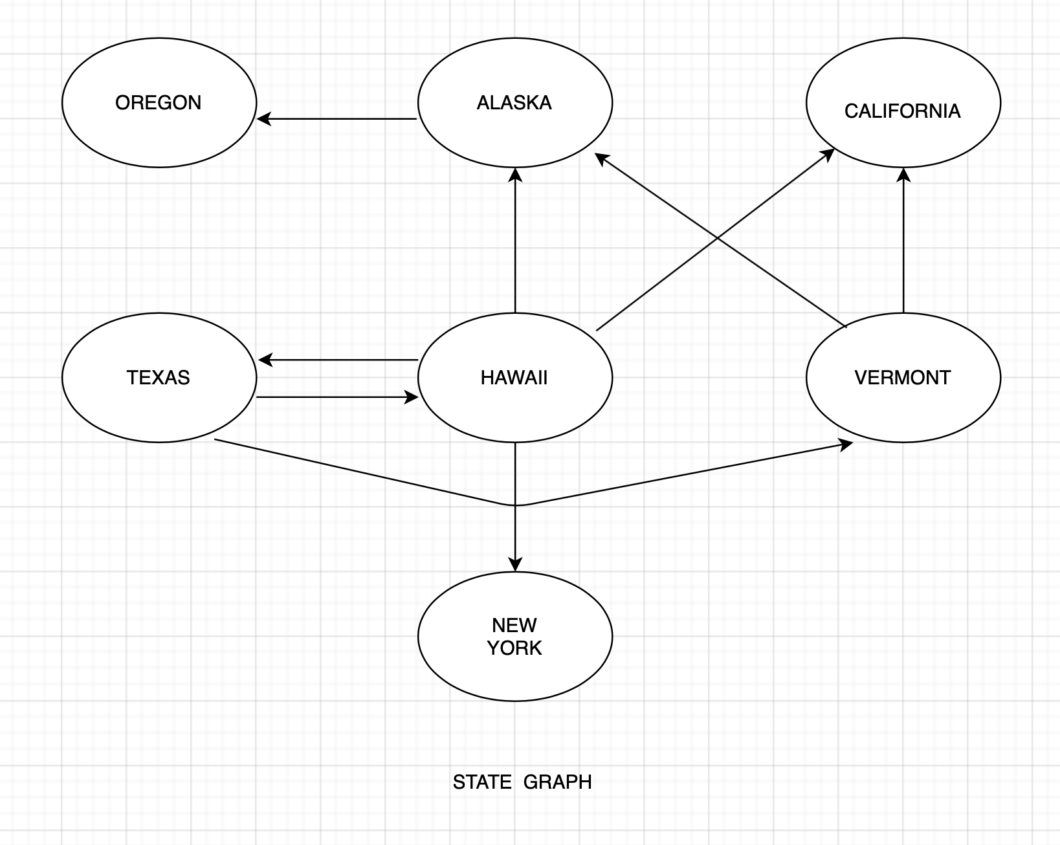

V (State Graph): {Oregon, Alaska, Texas, Hawaii, Vermont, New York, California}

E (State Graph): {(Alaska, Oregon), (Hawaii, Alaska), (Hawaii, Texas), (Texas, Hawaii), (Hawaii, California), (Hawaii, New York), (Texas, Vermont), (Vermont, California), (Vermont, Alaska)}

**2.** a) there is no path from Oregon to any other state.

b) there is a path from Hawaii to every other state.

c) from texas there is path to Hawaii

**3.** a) Adjacency matrix

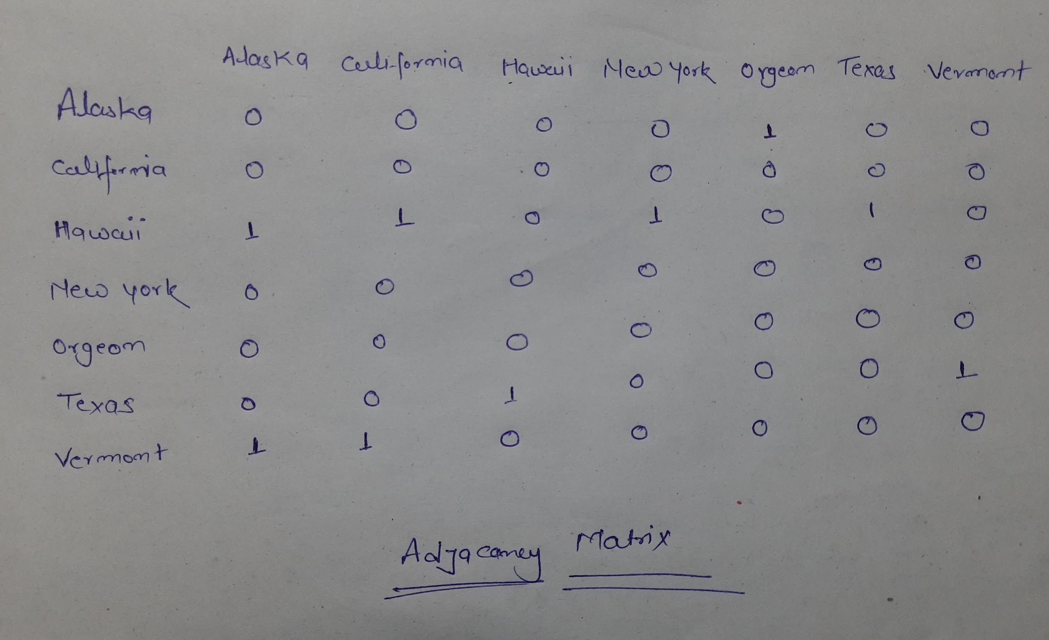

**3.**b) Adjacency List

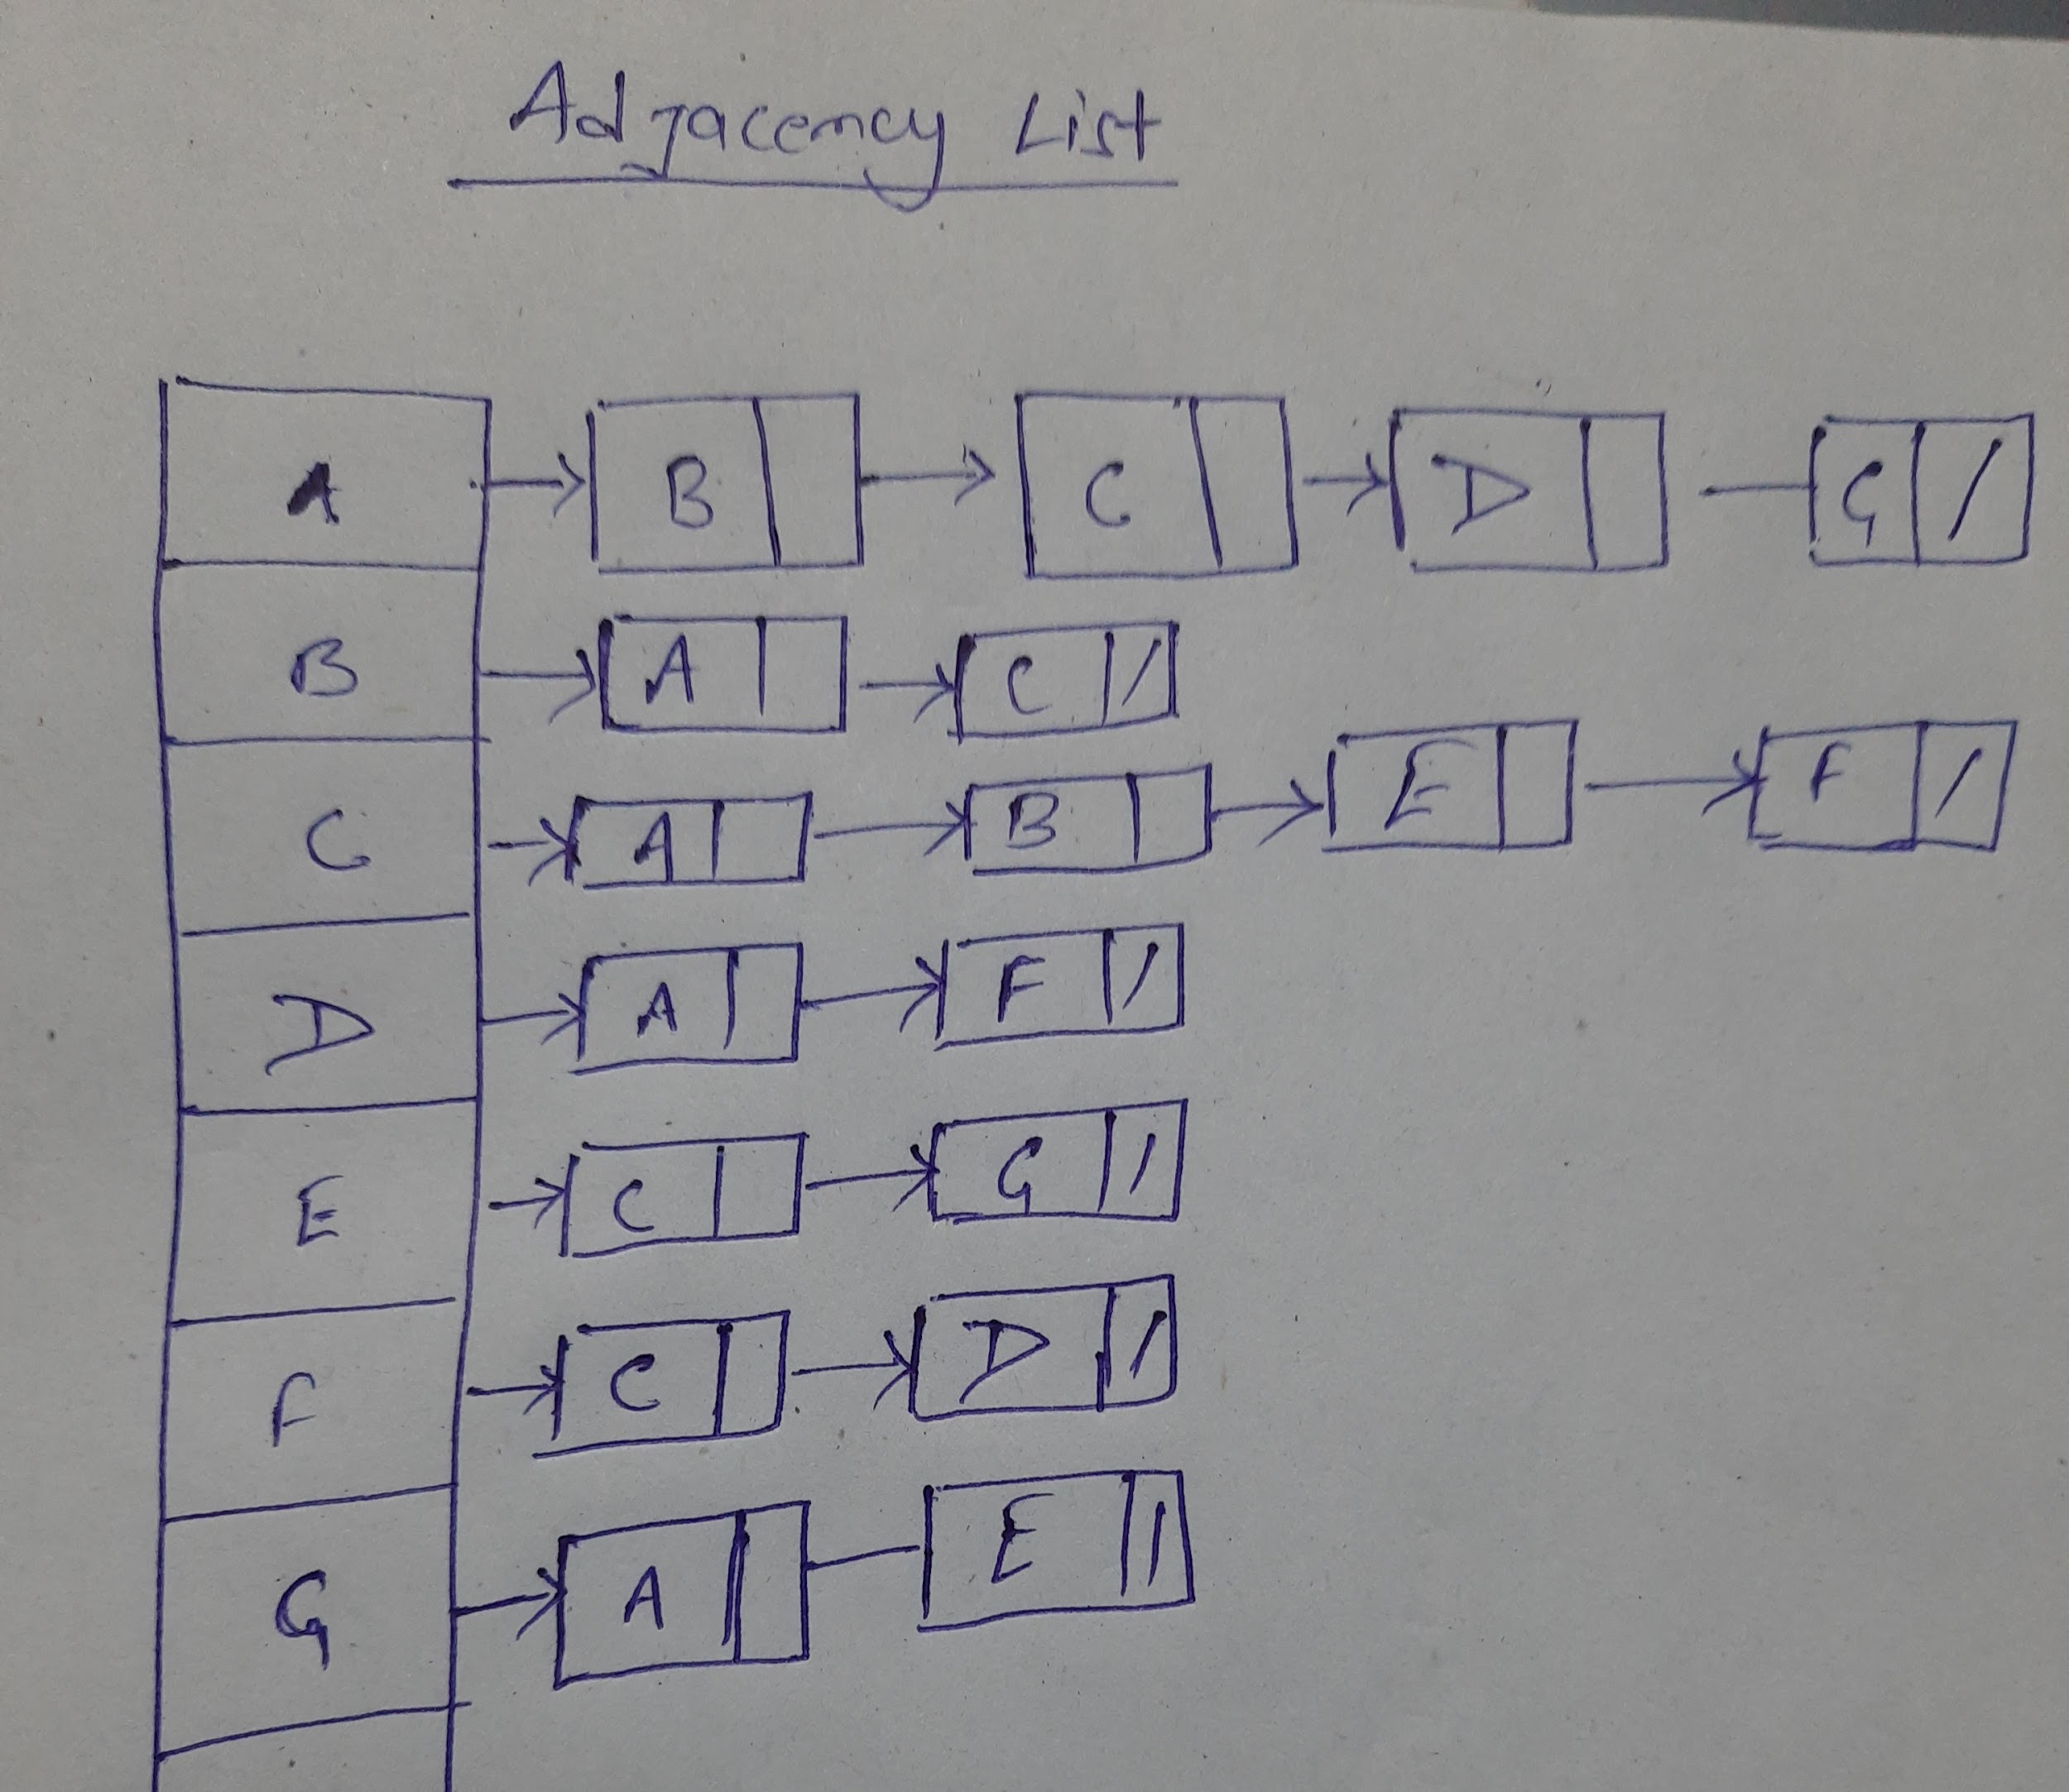

**4.**a) DFS traversal starting from E

Option (C)

E G A D F C B

**4.**b)

Correct option (d)

A,b and c are all breadth first traversals

**5.**

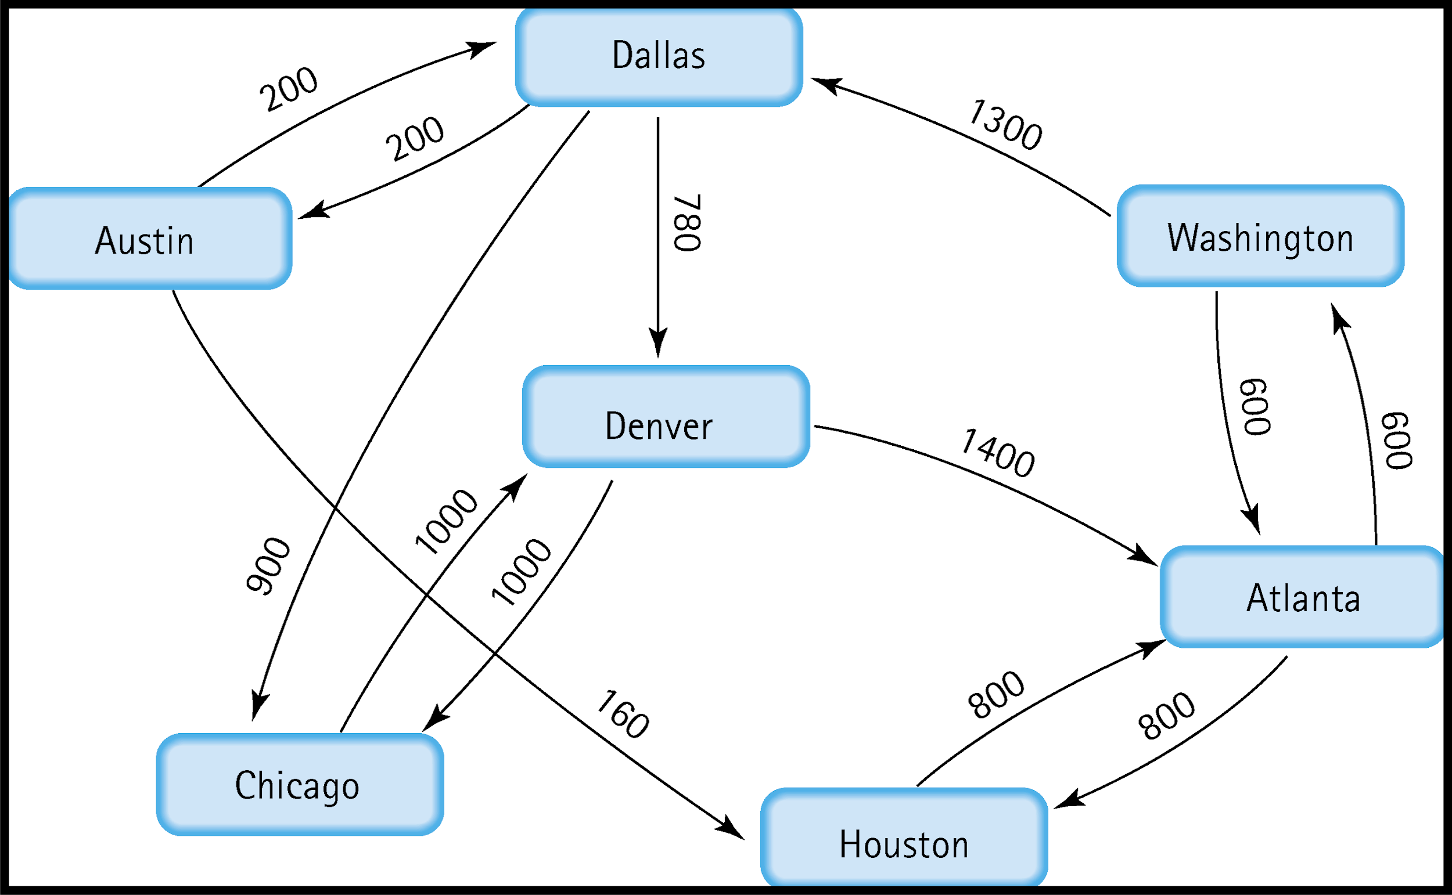

Shortest distance from Atlanta to Houston

:- 800 (directly distance)

Shortest distance from Atlanta to Washington

:- 600 (directly distance)

Shortest distance from Atlanta to Dallas

:- 600+1300= 1900

Shortest distance from Atlanta to Denver

:- 600+1300+780=2680

Shortest distance from Atlanta to Chicago

:-600+1300+900=2800

Shortest distance from Atlanta to Austin

:-600+1300+200=2100

**6.**

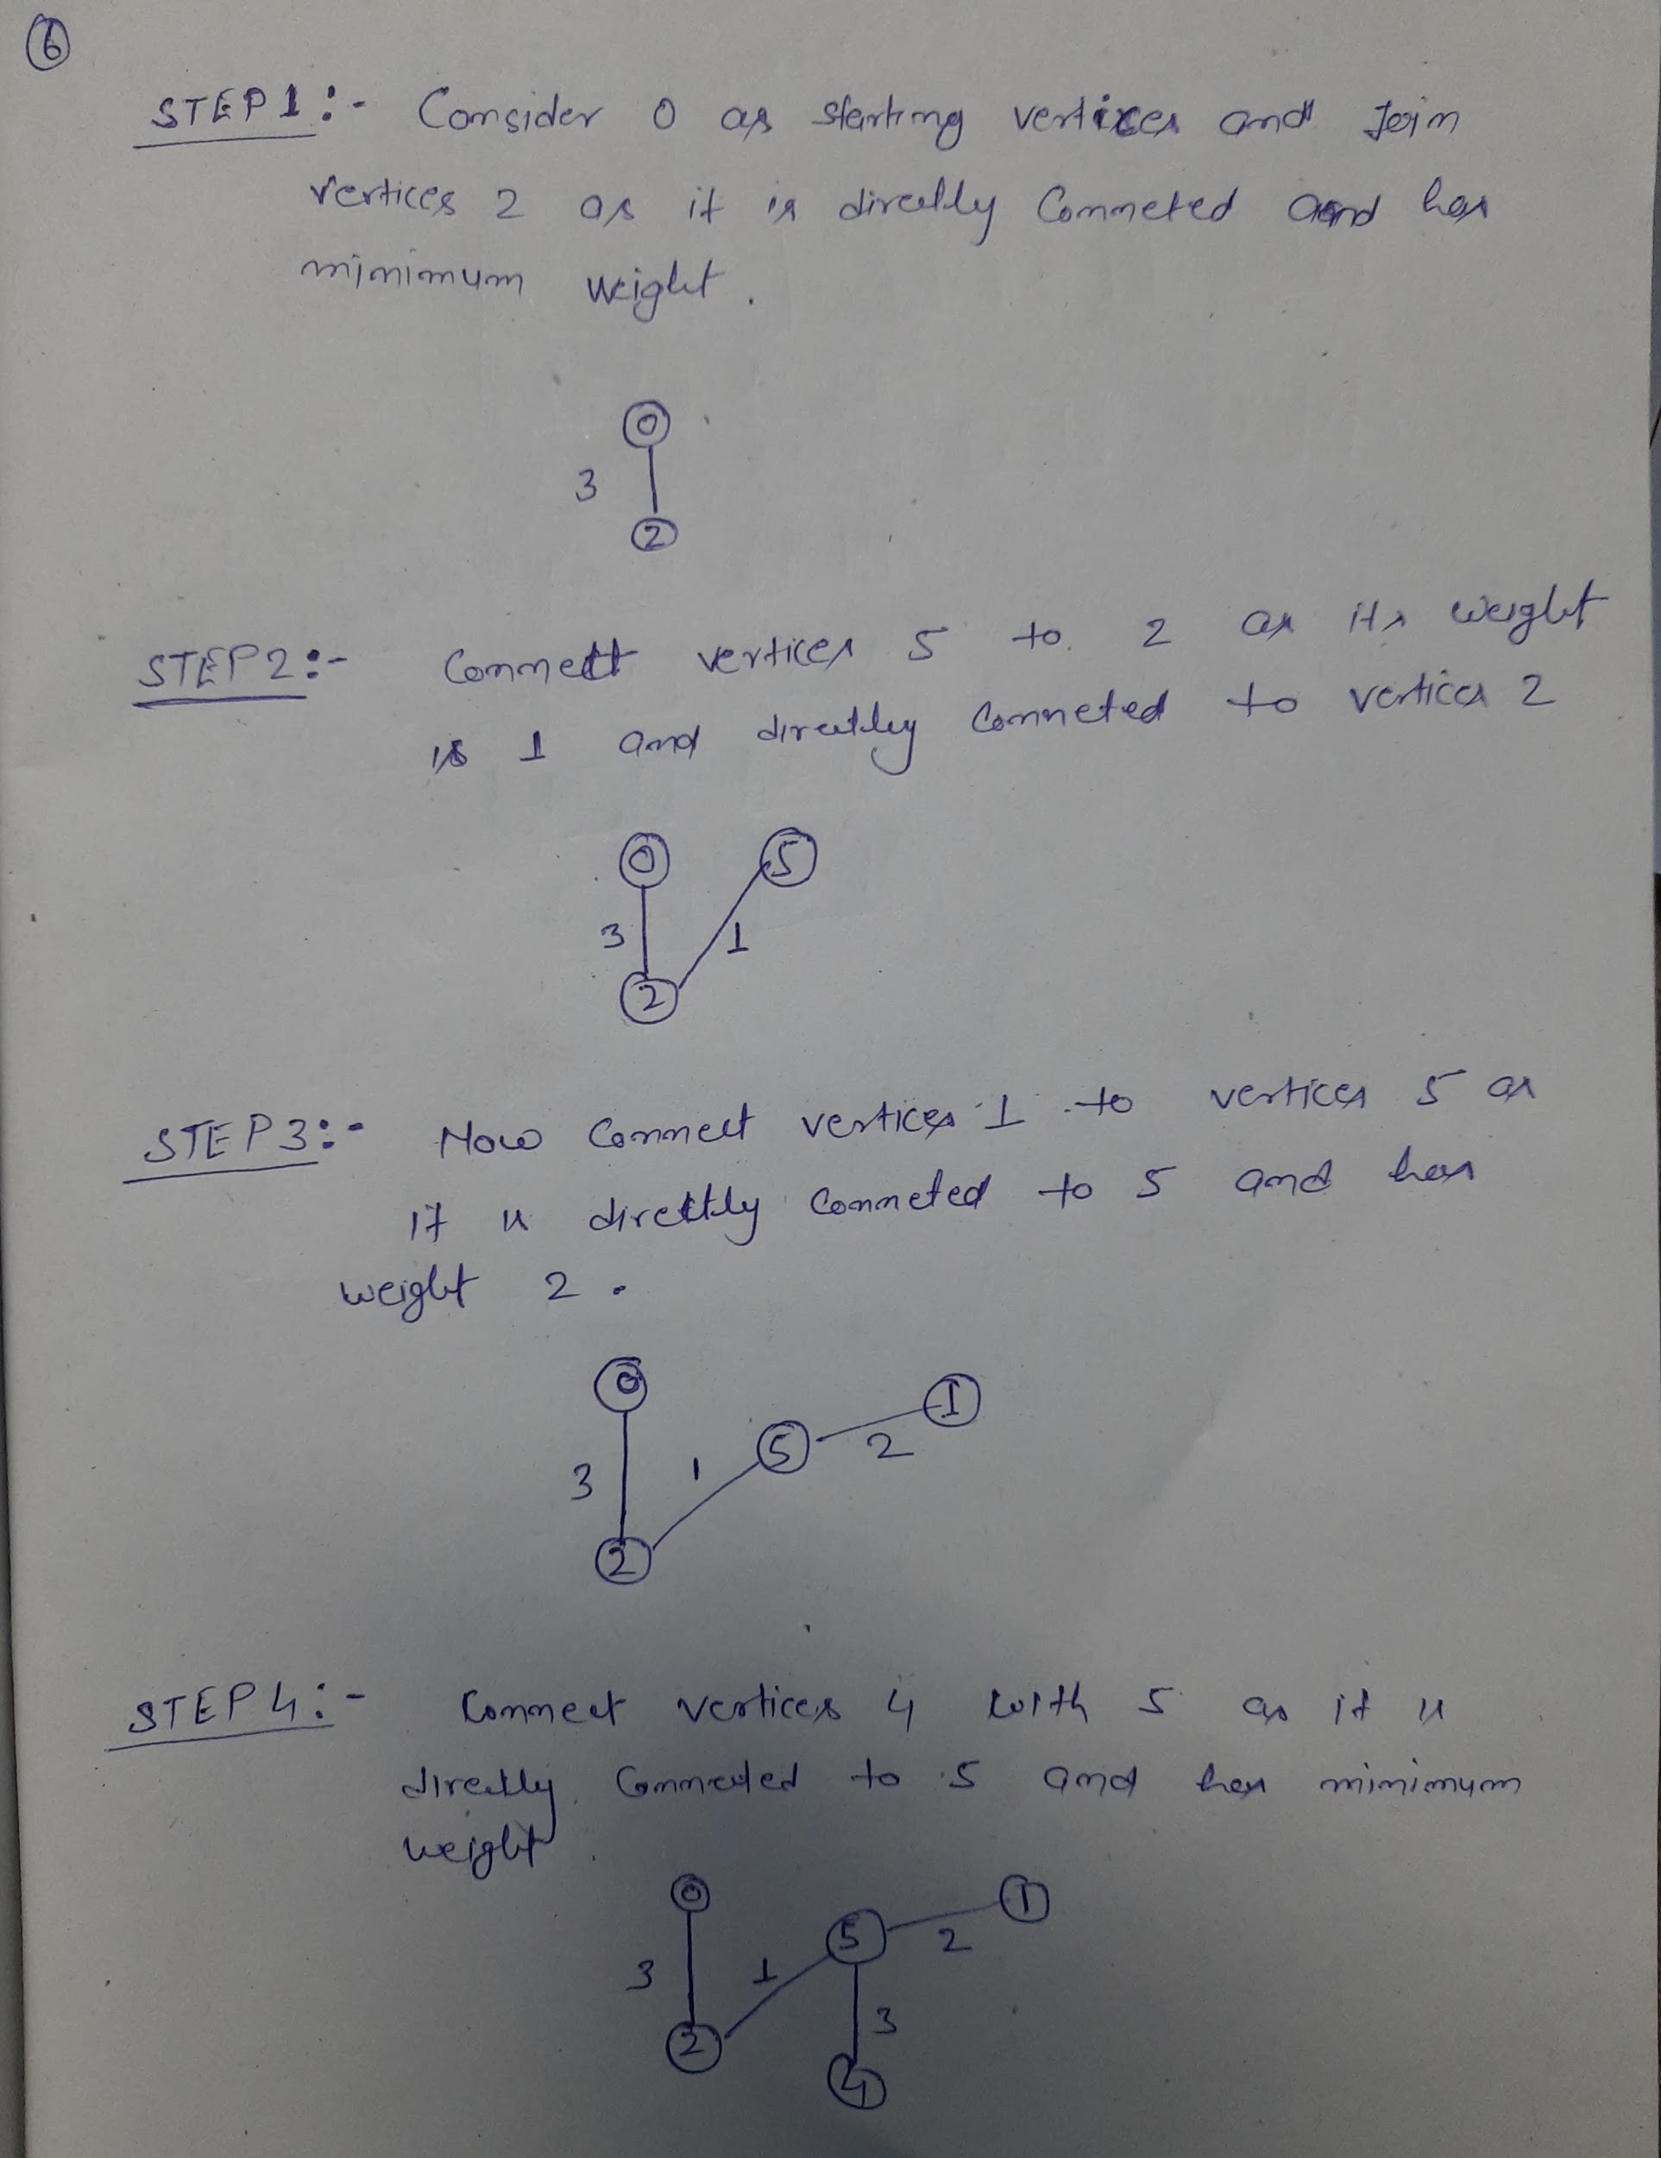

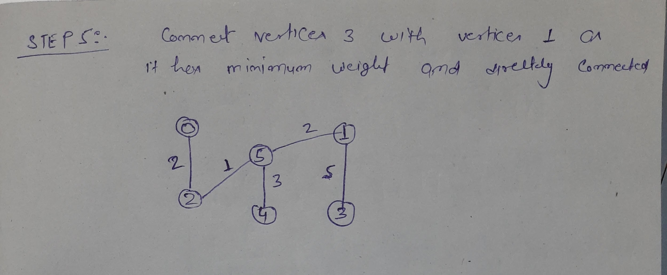

**7.**

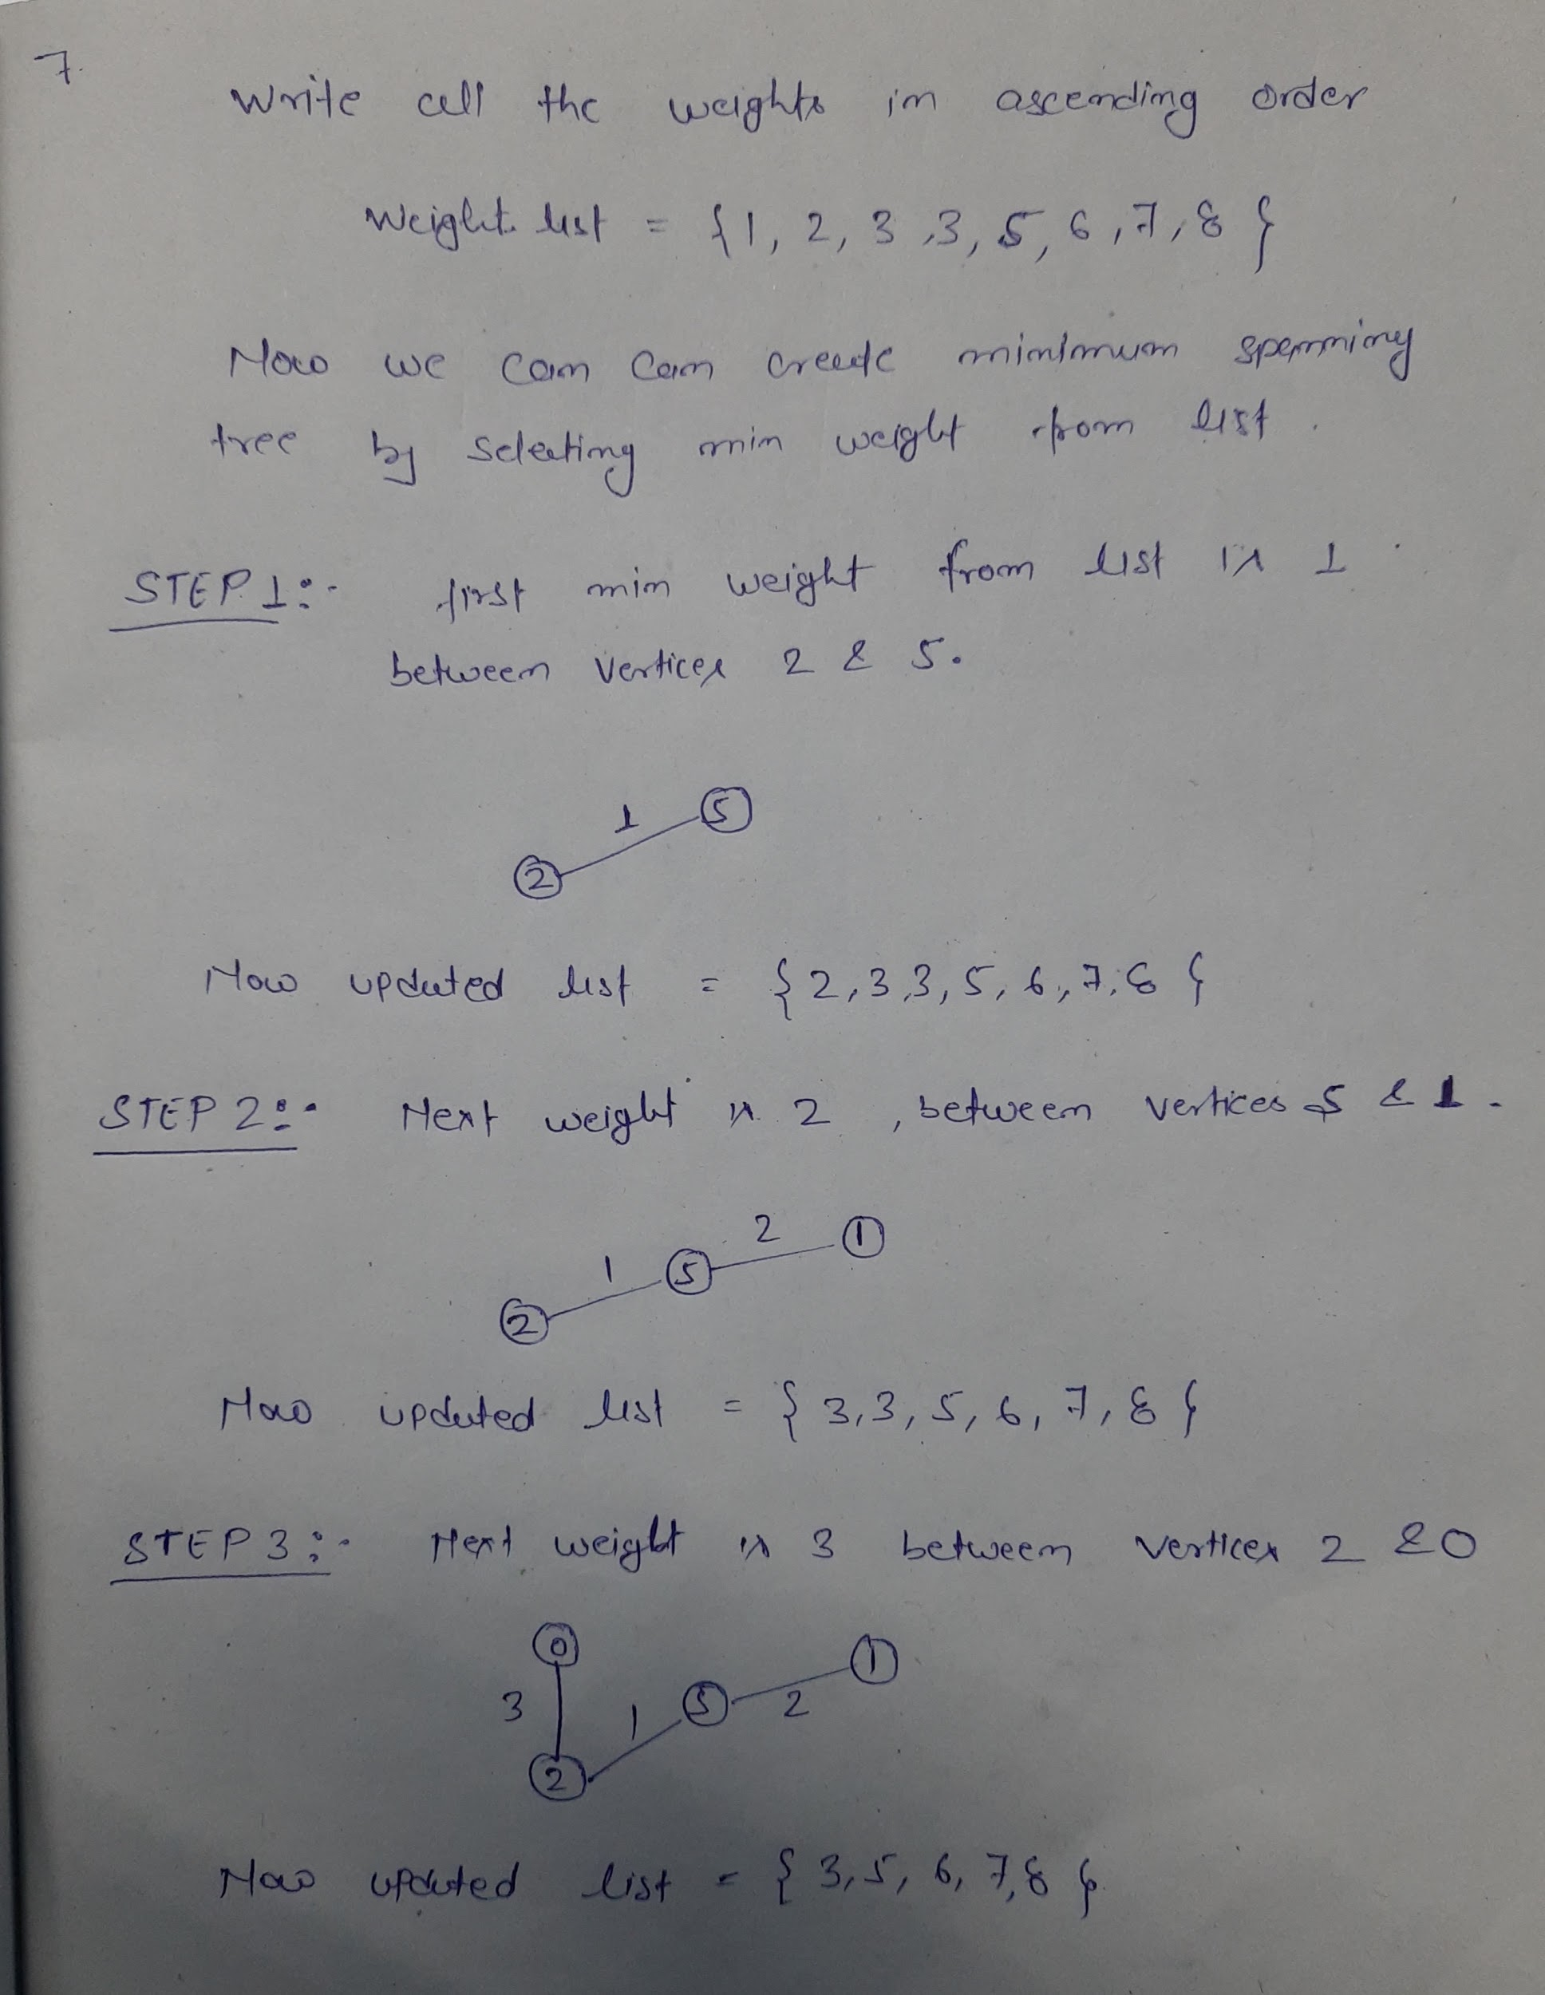

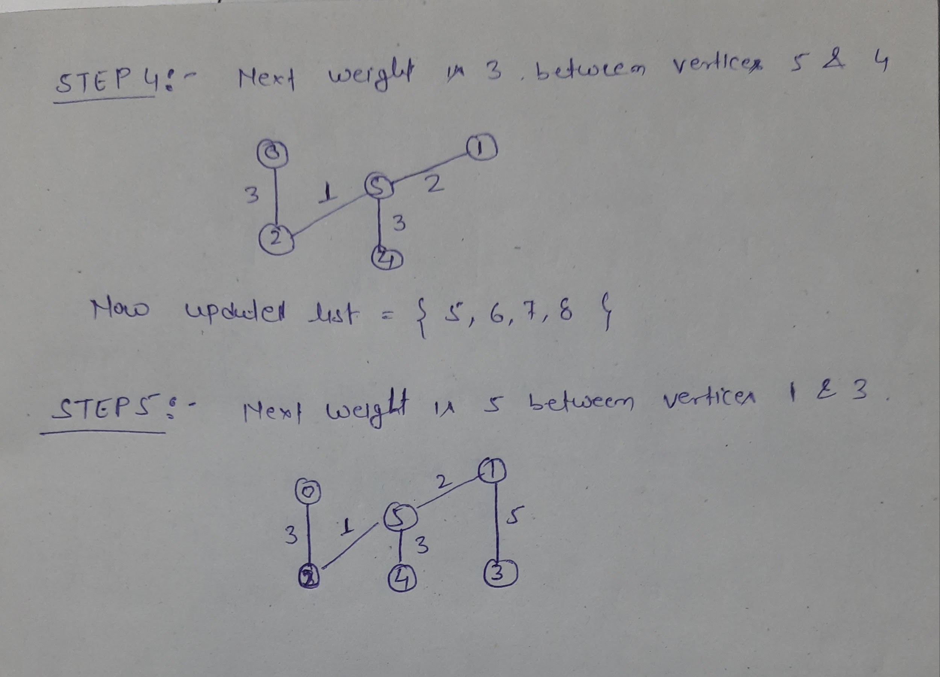

**8.**

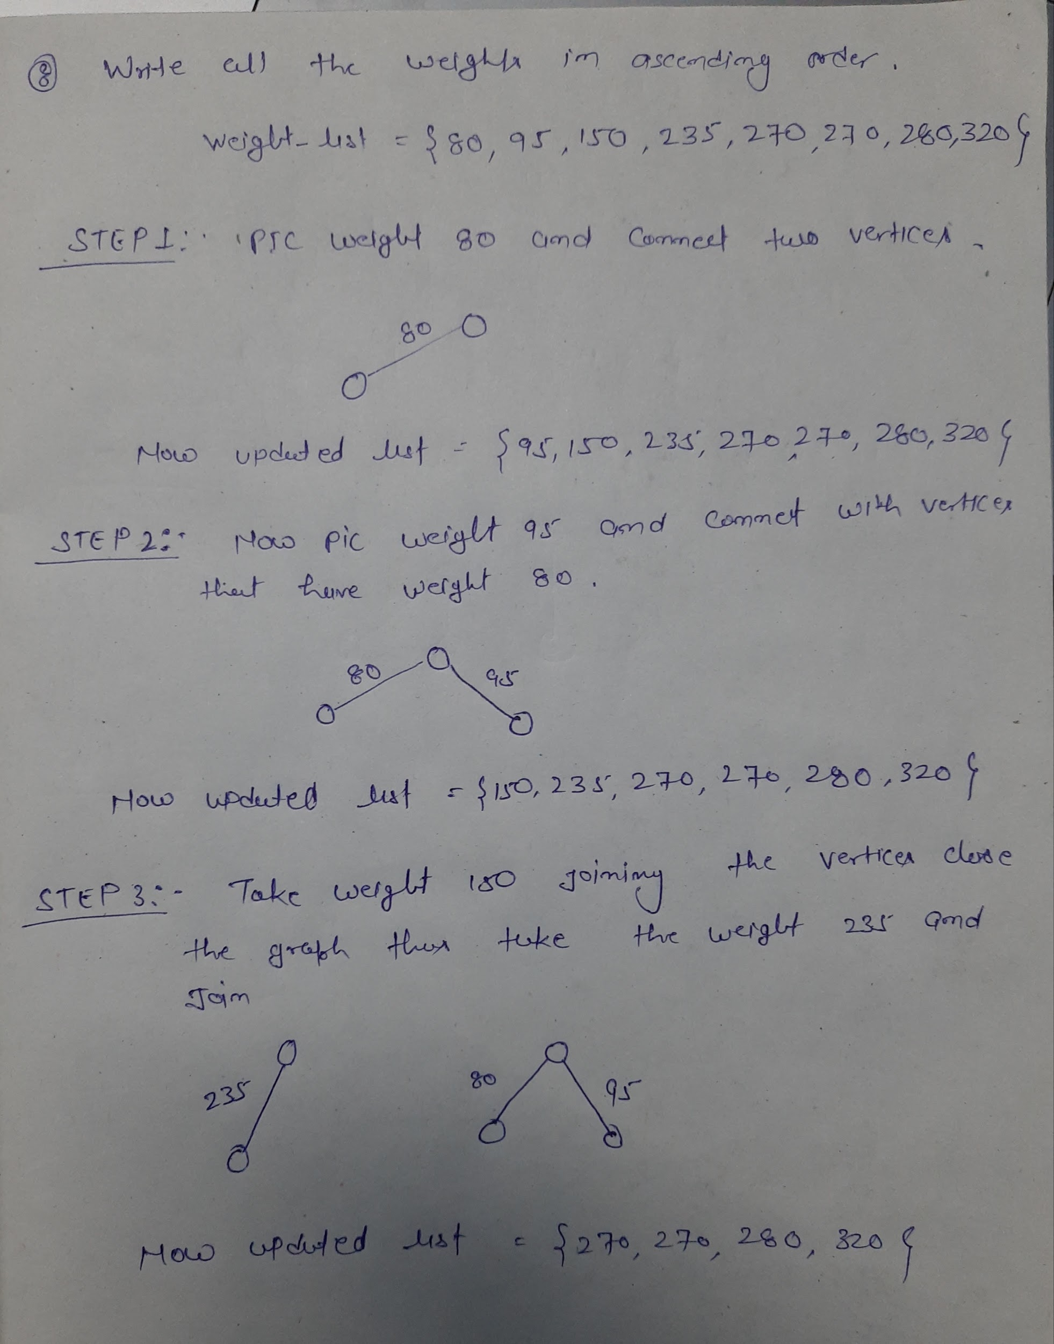

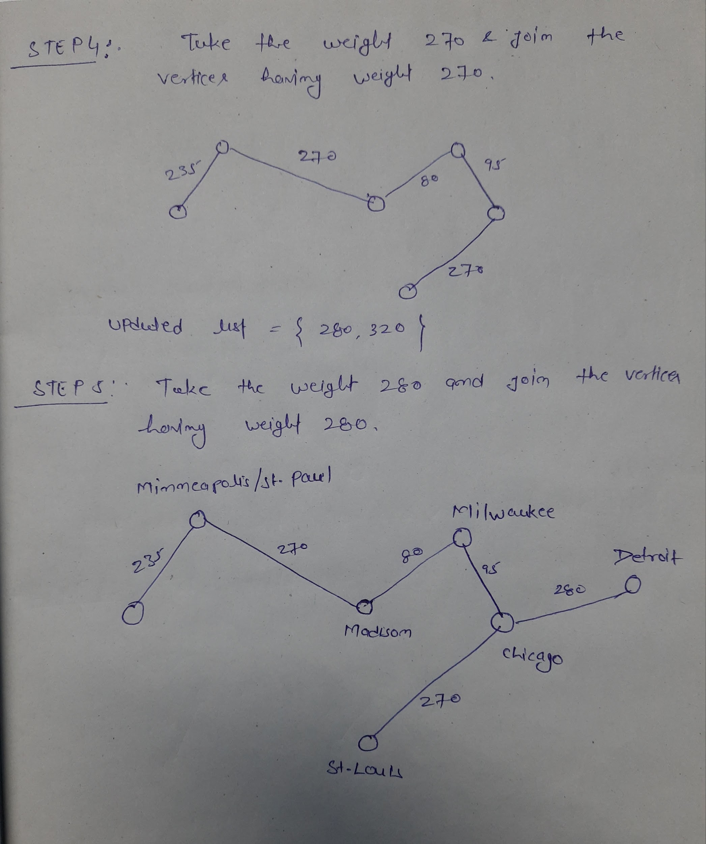

**9.**

1st Column: predCount

2nd Column: topologicalOrder

3rd Column: queue

Step 1:

|  |  |  |  |  |  |  |  |  |  |
| --- | --- | --- | --- | --- | --- | --- | --- | --- | --- |
| **0** | **1** | **2** | **3** | **4** | **5** | **6** | **7** | **8** | **9** |
| 0 | 1 | 1 | 3 | 3 | 2 | 2 | 0 | 2 | 2 |
|  |  |  |  |  |  |  |  |  |  |
| 0 | 7 |  |  |  |  |  |  |  |  |

Step 2:

|  |  |  |  |  |  |  |  |  |  |
| --- | --- | --- | --- | --- | --- | --- | --- | --- | --- |
| **0** | **1** | **2** | **3** | **4** | **5** | **6** | **7** | **8** | **9** |
| **0** | **0** | **1** | **3** | **3** | **1** | **2** | **0** | **2** | **2** |
| **0** |  |  |  |  |  |  |  |  |  |
| **7** | **1** |  |  |  |  |  |  |  |  |

Step 3:

|  |  |  |  |  |  |  |  |  |  |
| --- | --- | --- | --- | --- | --- | --- | --- | --- | --- |
| **0** | **1** | **2** | **3** | **4** | **5** | **6** | **7** | **8** | **9** |
| **0** | **0** | **1** | **3** | **2** | **1** | **1** | **0** | **2** | **1** |
| **0** | **7** |  |  |  |  |  |  |  |  |
| **1** |  |  |  |  |  |  |  |  |  |

Step 4:

|  |  |  |  |  |  |  |  |  |  |
| --- | --- | --- | --- | --- | --- | --- | --- | --- | --- |
| **0** | **1** | **2** | **3** | **4** | **5** | **6** | **7** | **8** | **9** |
| 0 | 0 | 0 | 2 | 1 | 0 | 0 | 0 | 2 | 1 |
| 0 | 7 | 1 |  |  |  |  |  |  |  |
| 2 | 5 | 6 |  |  |  |  |  |  |  |

Step 5:

|  |  |  |  |  |  |  |  |  |  |
| --- | --- | --- | --- | --- | --- | --- | --- | --- | --- |
| **0** | **1** | **2** | **3** | **4** | **5** | **6** | **7** | **8** | **9** |
| 0 | 0 | 0 | 2 | 0 | 0 | 0 | 0 | 2 | 1 |
| 0 | 7 | 1 | 2 |  |  |  |  |  |  |
| 5 | 6 | 4 |  |  |  |  |  |  |  |

Step 6:

|  |  |  |  |  |  |  |  |  |  |
| --- | --- | --- | --- | --- | --- | --- | --- | --- | --- |
| **0** | **1** | **2** | **3** | **4** | **5** | **6** | **7** | **8** | **9** |
| 0 | 0 | 0 | 2 | 0 | 0 | 0 | 0 | 1 | 1 |
| 0 | 7 | 1 | 2 | 5 |  |  |  |  |  |
| 6 | 4 |  |  |  |  |  |  |  |  |

Step 7:

|  |  |  |  |  |  |  |  |  |  |
| --- | --- | --- | --- | --- | --- | --- | --- | --- | --- |
| **0** | **1** | **2** | **3** | **4** | **5** | **6** | **7** | **8** | **9** |
| 0 | 0 | 0 | 1 | 0 | 0 | 0 | 0 | 0 | 1 |
| 0 | 7 | 1 | 2 | 5 | 6 |  |  |  |  |
| 4 | 8 |  |  |  |  |  |  |  |  |

Step 8:

|  |  |  |  |  |  |  |  |  |  |
| --- | --- | --- | --- | --- | --- | --- | --- | --- | --- |
| **0** | **1** | **2** | **3** | **4** | **5** | **6** | **7** | **8** | **9** |
| 0 | 0 | 0 | 0 | 0 | 0 | 0 | 0 | 0 | 1 |
| 0 | 7 | 1 | 2 | 5 | 6 | 4 |  |  |  |
| 8 | 3 |  |  |  |  |  |  |  |  |

Step 9:

|  |  |  |  |  |  |  |  |  |  |
| --- | --- | --- | --- | --- | --- | --- | --- | --- | --- |
| **0** | **1** | **2** | **3** | **4** | **5** | **6** | **7** | **8** | **9** |
| 0 | 0 | 0 | 0 | 0 | 0 | 0 | 0 | 0 | 0 |
| 0 | 7 | 1 | 2 | 5 | 6 | 4 | 8 |  |  |
| 3 | 9 |  |  |  |  |  |  |  |  |

Final Step:

|  |  |  |  |  |  |  |  |  |  |
| --- | --- | --- | --- | --- | --- | --- | --- | --- | --- |
| **0** | **1** | **2** | **3** | **4** | **5** | **6** | **7** | **8** | **9** |
| 0 | 0 | 0 | 0 | 0 | 0 | 0 | 0 | 0 | 0 |
| 0 | 7 | 1 | 2 | 5 | 6 | 4 | 8 | 3 | 9 |
|  |  |  |  |  |  |  |  |  |  |

**10.**

Topological order: -

Start

Discrete Math

Programming 1

Programming 2

Computer Organization

Algorithms

High-Level Languages

Operating Systems

Theory Computation

Senior Seminar

Compilers

End